Meadowmont Property Owner’s Association
2022 Fall/Winter Newsletter
Email: manager@meadowmontpoa.com
Dues questions treasurer@meadowmontpoa
P.O. Box 213 Arnold CA 95223-0213
(209)795-1973 website / meadowmontpoa.com

Happy Holidays!

Board of Directors
President Dave Gallagher, Sr.
Vice-President Michael Wever
Secretary Derrick Wydick
Treasurer Dick Brockett
Larry Sikma Director

Thank you Board Members
Thank you to all our current Directors for their efforts and contributions to MPOA. The Board meets on the second Tuesday of the month. Please visit our website for details on our next meeting. The Agenda is posted prior to each meeting and draft Minutes, when approved after each meeting. Only Agenda items may be acted upon at a meeting however members may address the Board during Open Forum. To place an item on the Agenda just contact our Manager Don Shinn at manager@meadowmontpoa.com

President’s Message

Looks like we dodged another bullet this summer, no major wildfire. Thanks for all the work that was done for Defensible Space.

Now let’s hope for a good winter. Lots of rain and snow, just not all at one time. Remember to help the county snowplow drivers by not parking on the roads during snow removal operations.

If this is another dry winter, we may have to protect our trees from the bark beetle by watering the trees. There are things you can do but by far the best defense is for the tree to have water during the winter months. Read the back page of your Calaveras County Water District bill for current water restrictions.

We wish you all a Merry Christmas and a Happy New Year!

Insurance
MPOA maintains Insurance in compliance with our CC&R and State mandates. Our Insurance Broker is William Yates/ Step / 925-818-4500. Our Certificate of Insurance coverages is posted on our Website.
Annual Assessment
The approved 2022-23 Pro Forma Budget has been approved and the Assessment remains $24.00 per year, per property effective July 1, 2022. Our Budget disclosures were mailed with the 2022/23 Spring Newsletter/Budget Notice. Payment was due on July 1, 2022. Reminder notices have been sent if we have not received your Assessment payment. Checks only Please.
It is now delinquent and is subject to a $10 late fee plus monthly interest on your outstanding balance. The Budget packet is available on our website. Our website contains lots of information and documents for members & prospective members, Title companies and Realtors. Enclosed in this mailing is our 2021-22 Annual Financial Report for member review.
Important Phone Numbers (209 Area Code must be used)
- County Sheriff 754-6500 OR Emergency 911
- Highway Patrol 943-8600 Street Parking Violations
- County Road Repair 754-6402 Street signs, Plowing, Pot holes, Culverts
- Animal Services 754-6509 Noisy Pets
- Code Compliance 754-6326
- Health Dept / Septic 754-6400

Our CC&R, the Sheriff and Ebbetts Pass Fire want to remind everyone to please maintain a legible address sign on all your properties. Aluminum reflective address signs are available at our Sheriff substation next to Big Trees Market and they are only about $20. Top to bottom, left to right, either one, and/or both sides are all available. These are crucial during an emergency, Lot inspections and are also required through our Public Resource Code.. THANK YOU!

PET / Animal WASTE It seems that a constant problem in our community is animal waste left on properties. It smells, attracts flies and is just not healthy. Feral Cats, Dogs, Bears and Raccoons are some of the culprits and also, owners who don't pick up after their pet. Please carry plastic bags and clean up the waste when you walk your pet. Owners also need to remove waste along the roadway in front of your property. Either dig a hole and bury it or bag it and drag it to your garbage can.

Are you having problems with barking dogs, dogs running loose? Always nice if you can talk with your neighbors and work it out. If not call County “Animal Services” 209-754-6509. All complaint calls are logged and tracked. At some point they will be obligated to notify your neighbors and if there is no progress, citations are sent, then Hearings can follow. Do call, so they can start tracking your complaints.

ART: If you like to hike, try the Arnold Rim Trail that travels behind Meadowmont. It has a number of access points including: The Logging Museum at White Pines lake and Fairway Drive along the US Forest Service property and at Cedar Center. You may visit their website at arnoldrimtrail.org for special events and volunteer trail work efforts. They now have new trail maps on their site for download and signs along the Trail.
MPOA Website: Remember to visit our Association website for current information. The website offers great contact information, a posting of the upcoming agenda for each month’s Board meeting, Minutes of the previous month’s meetings, as well as community updates, documents and Realtor information. www.meadowmontpoa.com
Share the Road
Please SLOW DOWN and obey the 25mph speed limit on all residential roads in Meadowmont! Our roads are snow plowed by the County and they also maintain the culverts (except under your driveway). Call 209-754-6402 for all road repairs, plowing and signage problems. Vehicles, always share the roadway with pedestrians, bicyclists, skateboarders, dog walkers, children at play, and others … not to mention, wild animals, large and small!!! With hilly crests, curves and trees blocking visibility, excessive speed is DANGEROUS!!! Please drive slow & carefully during the winter months. Also please don’t interfere with snow plowing this winter. If you have snow problems just call the County.
Parking along County roads is limited to 72 consecutive hours. Boats, trailers and vehicles can be reported to the Highway Patrol for citation & tow at
209-943-8600

Medical Air Lift Helicopter Insurance
If you own property or have a legal residence in the Ebbetts Pass Fire District, you do not have to pay for EPFD ambulance service, it’s included in your property tax. If you do have insurance that covers all or some of the cost, EPFD will take that as payment.
If, for some medical emergency, you need to be “MEDI FLIGHTED” out via helicopter, it may cost many thousands of dollars. Very few medical insurance companies cover for that service.
Air Medcare Network ???????1-800-793-0010 provides coverage for as low as $50.00 per year, per household, to cover air ambulance. Meadowmont property owners are offered a discount so please let them know this if you choose to purchase coverage.

Calaveras County Urges Property Owners to Return Right of Entry Forms for the Tree Mortality Program
FIRE SAFETY Calaveras County 209-754-2890 is offering FREE dead/dying tree removal to Calaveras County residents that have dead and dying trees located on their property along County roads. This program, known as the Tree Mortality Program is funded through the California Disaster Assistance Act, and results in NO COST to the landowner. To qualify for the program you must have a dead tree on your property that could hit a County road if it falls. Program foresters have recently completed surveys and located dead/dying trees in Arnold. Program foresters have created seven project areas with identified trees, and mailed Right of Entry Forms to each landowner where trees have been identified. Forms have only been mailed to landowners who have trees that are qualified for the program.
Members please clean your properties of forest debris and dead/dying trees in order to be in compliance with PRC 4291 guidelines posted on our website. Compliance is a year round effort.
PRC 4291 Improved property inspections are done by CalFire
PRC 4291 Unimproved Property Inspections are being conducted by Ebbetts Pass Fire. All Properties need to comply with California Public Resources Code PRC 4291 year round. The code requires 100 feet of defensible space and reduced fuel zones around buildings and lifting tree limbs. The requirements are clearly described in their brochure, “Make Your Home (And Community) Fire Safe.” In addition to peace of mind, those in compliance avoid steep fines and court appearances. Clearing your property of fire fuels can make the difference between having your home destroyed or passed over by fire fighters. Defensible space works! We understand that the County, at the direction of Firewise has adopted new setback and fire proof building material requirements for all new construction. Check with the County for these new requirements during your permit process. Did you know that major efforts continue to circumnavigate Arnold with fire breaks? The one in the Forest behind Meadowmont was completed last year. A controlled burn was just completed in Big Trees State Park. A big thank you to a number of volunteers who are dedicated to Fire Safe efforts. Please do your part and keep your lot clean of Forest Debris year round.

White Pines Lake Want to know what’s going on at White Pines Lake and picnic area? Just visit their website at whitepinespark.com. On site donation boxes and other donations will be appreciated to keep this wonderful non-profit recreation area clean and ready for your enjoyment. THANK YOU to the numerous volunteers who help keep the park in good shape. Please pack out your garbage after use. Just take pictures and leave footprints!
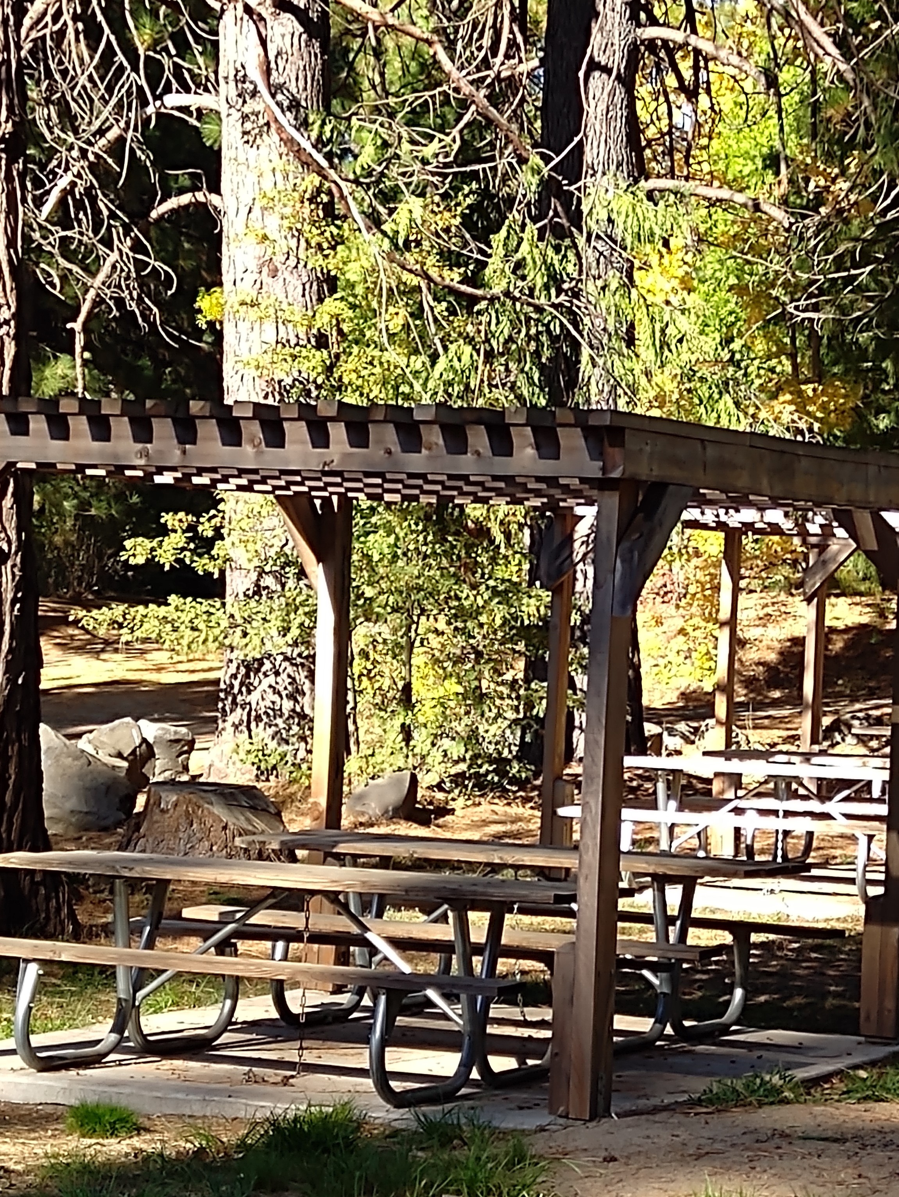
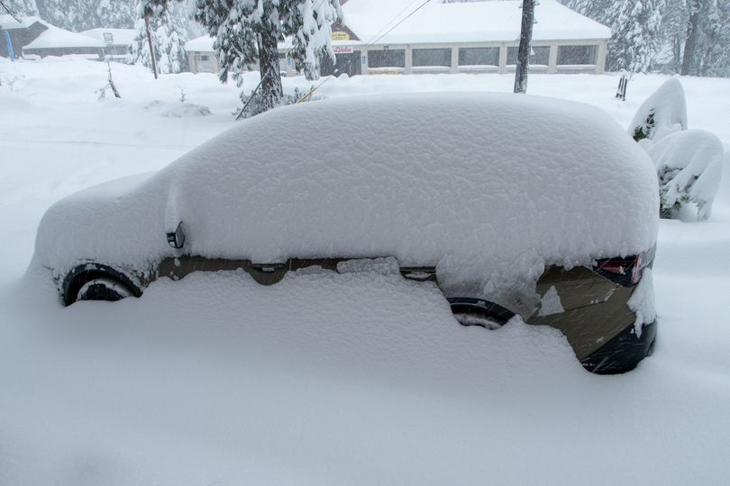
ARE YOU READY?
Winterize your Home - Get Ready for SNOW
Time to get ready for winter storms. Clean your rain gutters, downspouts and roofs and keep your firwood dry. Store your gasoline for your snow blower and your generator and check your batteries and flashlights/candles. Change your furnace air filters and clean your fireplace flue if necessary.
Eliminate ember-catchers: Sparks, firebrands, and burning embers may blow miles from a wildfire and rain down on your home for hours. These will land on, under, and around your house in any place that rain, snow, leaves, and pine needles fall. During fire season, frequently check and clean all nooks and crannies, especially on roofs, gutters and decks; and under and around porches, stairs, deck furniture, potted plants, storage areas, and vehicles.
Move your woodpiles as far as possible from buildings, trees and power lines; at least during fire season. Surround with 10’ of cleared area and cover with fire resistive material, securely tied down. Flying embers from wildfires can easily burn through plastic tarps and ignite woodpiles, creating an inferno beside your home. Also clear around your propane tank. Always follow PRC 4291 and trim limbs, remove dead trees and get rid of any fire ladders.
Would pets survive if you weren’t home? Could your home stand alone without firefighter protection? A fast-moving fire may reach your home before firefighters arrive. Intense heat and heavy smoke from vegetation burning near doghouses, kennels, corrals and barns can kill your furred or feathered friends. Clear around your pets’ areas the same as you would clear around your own home. Don’t forget batteries and flashlights if we lose power.
For more information on Public Resources Code (PRC) 4291 and making your home safer from fire, visit these websites: www.fire.ca.gov; www.firewise.org; www.firecenter.berkeley.edu/toolkit; or contact your local CAL FIRE Station or the CDF Tuolumne-Calaveras Unit Fire Prevention Bureau at 209-754-3831.
PG&E is now offering more tree and debris removal services around their power lines. We all experience downed trees, limbs and pine needle debris that will need to be removed in order for our lots to be in compliance with PRC 4291. CAL-FIRE (209-795-1542) supervises the cleaning of improved lots and Ebbetts Pass Fire District (209-795-1646) is responsible for vacant lots. Members may choose to work with their neighbors, to hire a chipper and trailer and remove their debris with a group effort. Cal Fire does have grants for seniors to help them clean their lots and remove debris. Apply early. Some residents like to pile and burn their debris. Please visit the CAL-FIRE website for information on how to safely burn your yard debris and burn permit requirements. No smoke piles please, keep your debris burning! Burn permits are required year round, during the periods that burning is allowed. There are specific rules for burning which must be followed at all times and are the responsibility of the property owner. There are approved burn days and you can verify these dates by calling 209-754-6600. Cal Waste 209-795-1532 can also provide you with a small 3 yard dumpster if you use their weekly curbside removal services. Millers on HWY 4 will also only take yard waste for $10 per yard. Rock Creek 754-6403 is also available for dumping and recycling as is Red Hill 736-2144. Metal Bear safes are the best for storing your waste and keeping Bears out of your garbage. Tahoe makes these mandatory!
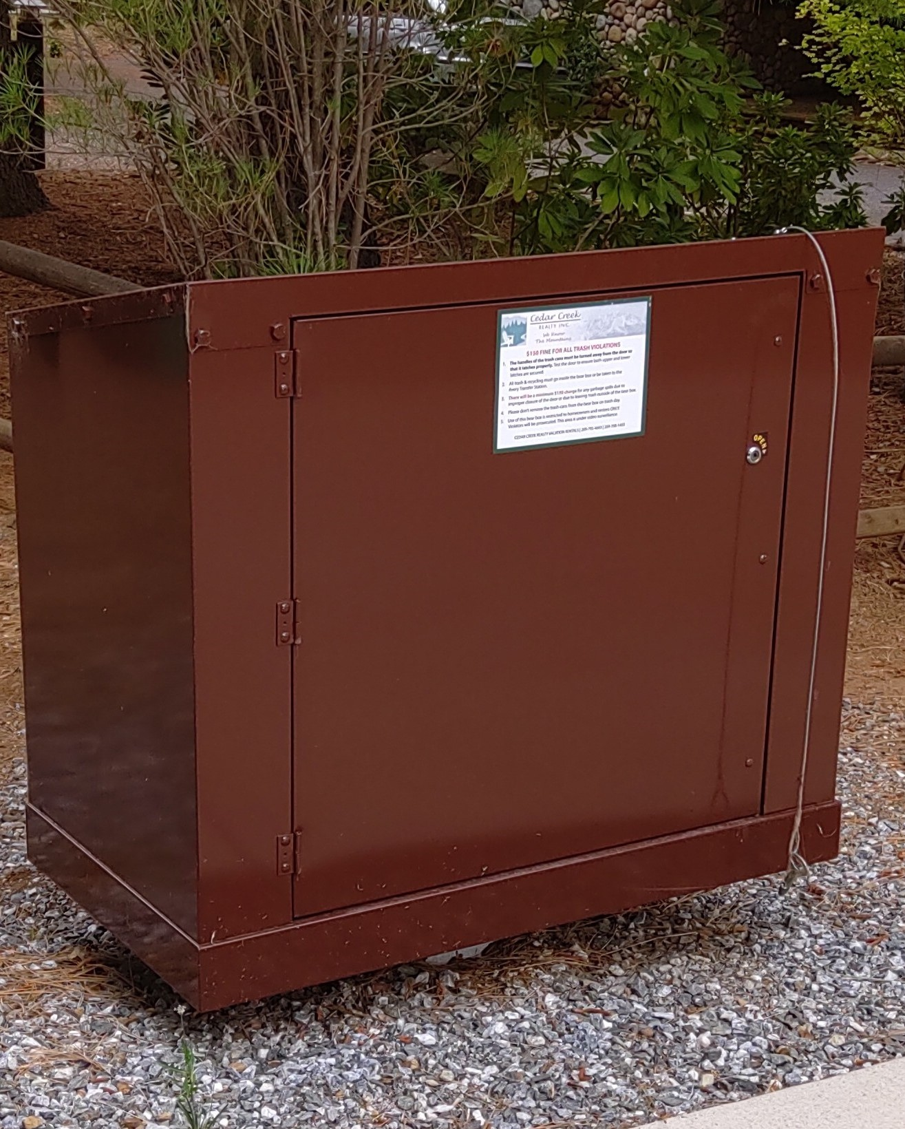

Refuse / Recycling Removal
AVERY TRANSFER STATION No Charge to Locals with ID
Formal ID checks may take place at the Avery Transfer Station for waste and recycling. Residents must have proper identification and/or vacation renters must produce a copy of their rental agreement at the gate. Please call the Avery Transfer Station for additional information at 209-795-3222. They are Closed Wed. & Thurs. Calaveras County has been notified that they are not meeting the State mandated recycling requirements. Everyone is encouraged to also use the transfer station for recycling or curbside weekly refuse and bi-weekly recycling services are available through CAL-WASTE. CAL-WASTE offers their weekly service customers one free dumpster per year for landscaping forest debris. Please call them at 209-795-1532 for more information.
MPOA Standing Committee Updates
Signs & Junk: Our Signs and Junk Committee advises that Advertising & Commercial signs are not allowed and Political & Real Estate signs & banners be removed promptly when events are over. Temporary Construction signs should also be removed when the job is done. Thank you for helping control sign pollution and Per the CC&R please keep your property neat and clean from refuse and debris and vendor advertising/sign pollution.
Building Review Committee (BRC): Per our CC&R, ALL exterior improvements to your property requires prior approval from the Association before any work being completed. . All exterior improvements DO require approval including fences, decks, sheds, driveways, new homes and all exterior additions/improvements. The form to request approval for this and trees can be found on our website on the Home Page.
PRC 4291 Committee responds to written complaints of violations. Notices are sent, Hearing held with potential fines. Violations are also shared with EPFD & Cal Fire. Violations also subject property owners and neighbors to Insurance rate increases and/or cancellation.

BEARS & CRITTERS A fed Bear can become a dead Bear! Please don’t share your garbage with critters and Bears. Install a metal locking Bear Safe to keep refuse secure! ACE Hardware has vendors.
Please keep your garbage containers secured so Bears don’t make a mess. Pet food should not be left on your deck. Shut your doors, keep your vehicles closed and secured. Bears can really do some damage if they get into your vehicle. Locking Metal Bear Safes are the best! We have had reports of Bears and a pack of coyotes roaming around looking for food. Keep you small pets inside and do not leave dog food where forest animals can find it.

